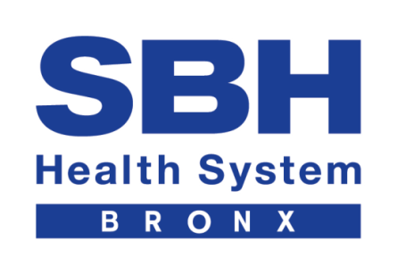

Job Description
Department: Emergency Medicine
Position TITLE: Volunteer for Stroke Education in ED
Reports To: Jeffrey Lazar and Alexxis Lawson
Date Revised: 8/6/19

NAME: ___________________________ DATE: _______________________

PRINCIPAL MISSION: To conduct brief educational interventions in the ED and the Waiting Room to better educate our community about Stroke Prevention and Early Recognition.

PRINCIPAL DUTIES AND RESPONSIBILITIES:

RESPONSIBILTIES

- Able to conduct brief educational interventions in the ED and the Waiting Room
- Able to conduct brief educational interventions out in the community as well
- Be interactive with staff, patient, and family in a compassionate and empathetic way
- Aid in creating a person-centered care environment
- Must have knowledge of community health disparities
- Abide by the policies and procedures of SBH Health System

QUALIFICATIONS:
- Speak English and Spanish
- Must be attentive and follow directions
- Must be available from September on
- High School and college students preferred
- Must have excellent interpersonal skills
- Must be able to communicate effectively

